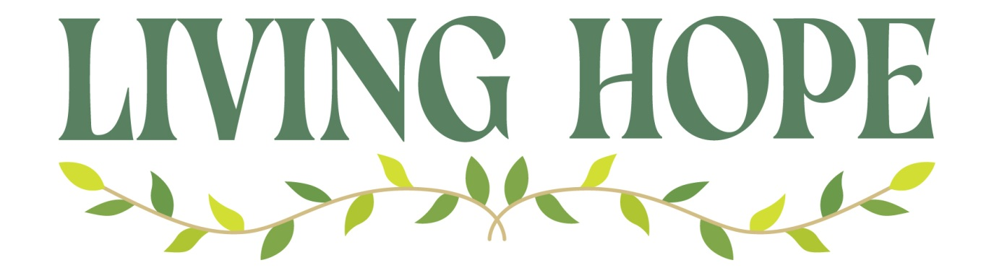

Wednesday 5th March **The Barn at St Wilfrid’s Arley**

**What is hope?** – *Exploring what hope means in the context of the*

*Christian faith.*

**Thursday 13th March Sunday School Room at Corley**

**Imperfect** – *Exploring how we hold on to hope in lives that are messy and a world that is imperfect.*

**Thursday 20th March Annex at St Laurence**

**Together** – *Exploring the ways joining with others allows us to find hope ourselves and offer hope to those who need it.*

**Thursday 27th March The Barn at St Wilfrid’s Arley**

**Trusting** – *Exploring what it means to trust in the hope God promises, even when we feel uncertain about the future*.

**Thursday 3rd April Sunday School Room at Corley**

**Noticing** – *Exploring how we can deepen our hope by noticing signs of what God is doing.*

**Thursday 10th April Annex at St Laurence**

**Courage** – *Exploring how being rooted in hope can give us courage to face difficulties and seek change.*

**Thursday 17th April The Barn at St Wilfrid’s Arley**

**Transformed** – *Exploring how God can transform even the most broken situations.*

NB - This will include a Soup Supper so booking is essential

***All sessions start at 7.30pm***

There are booklets available to buy £2.99

Digital versions of the reflections will also be available in the

Everyday Faith app via www.cofe.io/EverydayFaithApp